Homework #4

Due: 11/25

1. (40 %) A message *m*(*t*) is employed to modulate a RF carrier at *fc* in FM format.
   1. (3 %) Please write down the expression of this passband signal, *s*(*t*).
   2. (4 %) This signal can be expressed in its phasor representation as: . Please find the slow varying complex envelope .
   3. (5 %) Assume we employ weak modulation scheme, which means the maximum phase deviation ** is much less than unit. Then by applying Taylor series to the first order, we may obtain an approximation of *ex* = 1 + *x*. Please find the expression of this passband signal *s*(*t*).
   4. (8 %) To detect this signal, we may use a product modulator associated with a low-pass filter to demodulate the signal. The configuration of this receiver can be illustrated as the following diagram. Please specify what kind of *c*(*t*) you need to demodulate the signal and explain how it works.

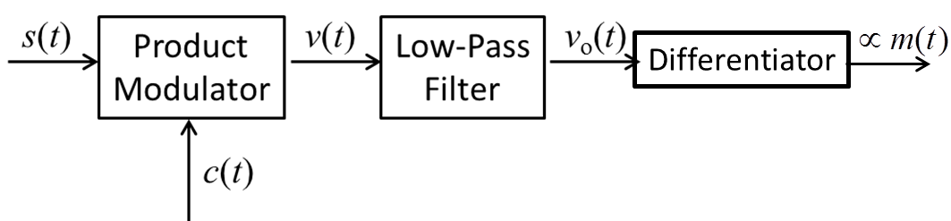

* 1. (5 %) Now if we have the message *m*(*t*) as  What is the bandwidth of message *m*(*t*)? Note you may need the following Fourier Transform pair: .
  2. (5 %) If we define the total energy of *m*(*t*) as , please find the message’s total energy.
  3. (5 %) Then we modulate it to obtain the transmitted FM signal *s*(*t*) as

.

Is it still a weak FM signal? Why?

* 1. (5 %) Based on Carson’s rule, please estimate the transmission bandwidth *BT* of this signal.

1. (15 %) Consider a wide-band PM signal produced by a sinusoidal modulating wave, *Am*cos(2*fmt*), using a modulator with a phase sensitivity *kp* rad/volt.
   1. (10 %) Show that if the maximum phase deviation of the PM signal is large compared with 1 radian, the bandwidth of the PM signal is linearly proportional to the modulation frequency *fm*.
   2. (5 %) Compare this characteristic of a wideband PM signal with the bandwidth of a wideband FM signal defined by Carson’s rule.
2. (25 %) This problem illustrates design choices and limitations for certain FM detector designs. Consider an FM system where the modulated signal is

,

where the carrier frequency is *fc* = 100 MHz. The modulating signal is , where *fm* = 3 KHz.

* 1. (5 %) What is the maximum value of *kf* such that *s*(*t*) can be demodulated using an ideal differentiator followed by an envelope detector?

For the remainder of this problem assume that *kf* = 10.

* 1. (3 %) What is the approximate bandwidth of *s*(*t*)? Is this NBFM or WBFM?.
  2. (5 %) Find the instantaneous frequency *fi*(*t*) of *s*(*t*). What are the maximum and minimum values of *fi*(*t*)?
  3. (7 %) Suppose that you demodulate *s*(*t*) using an ideal differentiator followed by an envelope detector. Assume a standard envelope detector as shown below, where the capacitor has capacitance *C* = 10−9 F. Propose values for the source resistance *Rs* and load resistance *Rl* such that the output of the envelope detector is approximately equal to *c*1 + *c*2*m*(*t*) for some constants *c*1 and *c*2. Is it possible to use this detection method if *fc* ≈ *fm*? Why or why not?



* 1. (5 %) Suppose that you use a zero-crossing detector for *s*(*t*). Find an expression for the minimum interval *T* for a zero-crossing detector such that there are at least four zero crossings in every interval *T*. Evaluate this expression.

1. (20 %) A composite angle modulated signal with carrier frequency at 106 Hz is expressed as:



1. (4 %) If this is an FM signal, what is the bandwidth of the message?
2. (4 %) Find the average power of this angle modulated signal. Assume the load resistance is 1 .
3. (4 %) What is the instantaneous frequency?
4. (4 %) At what time will we have the maximum frequency deviation *f*, and how much is it?
5. (4 %) Find the transmitted bandwidth of this signal by Carson’s rule.

Please note: Homework must be turned in by the beginning of class.

No late homework submission is allowable!